Student and Staff Engagement Plan for 2024/25:
The University of Chester is committed to embedding sustainability into all that we do. We aim to achieve net zero for scope 1 and 2 emissions by 2035 and baseline our scope 3 emissions, setting targets for reduction, and achieving our targets requires every one of us to act. Whilst we will make changes to the physical campus, how much energy we use, its sources etc., positive behaviour change will also be critical. Through our student and staff engagement plan, we want to ensure that students and staff have the chance to:
- Increase their knowledge on climate and nature emergencies.
- Understand how the university is responding to these crises.
- Learn what we can do at an individual and community level to act and make a difference.
- Actively contribute to creating a low carbon, liveable community.
We run several initiatives and campaigns to encourage behaviour change across the University so that sustainability will become engrained in all that we do.
This plan outlines our events and activities for 2025/26. For more information, please visit our events page and/or our Instagram profile.

Event | Description | Target audience | Date
Student induction | Induction activities will include:  - On site swap shop to give students access to affordable items.  - Recycling Roadshow with Veolia.  - Working with Residential Living to explain waste management in accommodation. | Students (1st year) | October 2025
Gardening sessions | Gardening sessions vary depending on the season and what needs to be done. Steered by the University’s Chaplaincy team and the student-led Gardening Society, and with the Sustainability team’s support, students can contribute to the University’s natural spaces at either of the following:  - University’s allotment space (Walpole Street, Chester).  - Community Hub Garden (Exton Park).  Students and staff can join our Allotment MS Teams channel to stay informed of planned sessions and produce that is available. | Students (all years) | Ongoing (weekly)
Carbon Literacy training | Carbon Literacy training covers the science behind climate change and the actions we can take to reduce carbon emissions. | Students (all years and of any course) and staff | Ongoing (termly)
Spring into Sustainability | Spring into Sustainability aims to improve understanding of and inspire action on climate change.  Collaborating with the Students’ Union and other teams (eg. Wellbeing, Chaplaincy & Volunteering), events/initiatives likely to take place as part of the month include:  - Pancake Day stall (17th February).  - On-site swap shop.  - Wellbeing walks.  - ‘Give it a Go’ Allotment sessions. | Students | February - April 2026
Sustainability Action Groups | Our Sustainability Action groups facilitate collaborative work across the University community to act on initiatives around:  - Energy, Emissions & Water.  - Biodiversity.  - Waste, Food & Resources.  - Sustainable Procurement.  - Travel & Transport.  The groups are designed to make sure groups from all departments are aware of the University’s sustainability targets and values and, more importantly, heard.  It is a chance to identify priorities, develop objectives, set targets, action plan, deliver discrete projects and review progress throughout the academic year. The Action Groups will also support the University’s work towards implementing the EcoCampus accreditation. | Staff and students | Ongoing (termly)
Moving Out campaign | A “pre-loved, re-loved” style campaign linking students, community members and charities (British Heart Foundation, Cheshire West Food Bank) together to redistribute unwanted items as students pack up/leave for the summer and reduce the amount of waste produced at the end of the academic year. | Students | April - July 2026
Staff talks | At each staff induction event, the  Sustainability team provides an overview of our sustainability policy, strategy and how staff can engage in our initiatives and activities.  The team will also have presence at the University’s satellite sites (Warrington and Birkenhead) when possible to ensure that the whole University community has opportunity to get involved and understand sustainable practices at Chester. | Staff (especially new starters) | Ongoing (termly)

Hedgehog Friendly Campus

The Hedgehog Friendly Campus is a student-led project supported by the British Hedgehog Preservation Society and aims to make the University’s sites a safe and attractive place for hedgehogs. Activities can include building hedgehog houses, keeping feeding stations topped up and organising litter picks. Hedgehogs are officially classified as vulnerable to extinction, so the project aims to make university spaces hedgehog friendly, as well as give people the tools to make their own spaces hedgehog friendly.

Environmental Management System (EMS)

An Environmental Management System (EMS) provides a structured framework to identify, manage and control activities undertaken by the University, that impact the environment – from how we manage our waste to the maintenance of air conditioning units. EcoCampus, has been developed specifically for colleges and universities to manage and improve their environmental performance.

The criteria outlined in EcoCampus conforms to the requirements of the international standard ISO14001:2015. The criteria are divided into four phases; bronze, silver, gold and platinum, where platinum achieves ISO14001, following an external audit process.

To support the implementation of EcoCampus, the Sustainability Committee established five Action Groups in 2024-25, which will continue into the new academic year:

- Energy, Emissions and Water.
- Biodiversity.
- Waste, Food and Resources.
- Travel and Transport.
- Sustainable Procurement.

Each Action Group identifies priorities, develops objectives, sets targets, carries out action planning, delivers discrete projects and reviews progress.

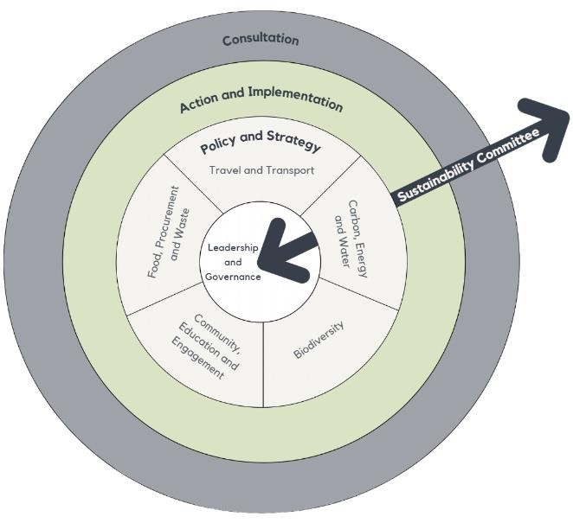
With an Environmental Management System (EMS) in place, we have identified 5 key working groups:
- Biodiversity.
- Carbon, Energy and Water.
- Community, Education and Engagement.
- Food, Procurement and Waste.
- Travel and Transport.

Within each of the Policy and Strategy groups, there is student and staff representation.
Collaborative working groups are comprised of members from across thematic strategic groups, to work together to develop and implement specific projects as required.

Image: Pathway to low carbon, liveable community

Our aim is to embed sustainability across all aspects of the University. Having regular communication, consultation, feedback gathering and input from staff and students is critical to shaping the sustainability agenda.

